# **Department of Computer Science and Engineering Islamic University of Technology (IUT)** A subsidiary organ of OIC

# **Lab Report 01**

# CSE 4616: Wireless Networks Lab

## 

## **Section:** 2A **Semester:** Summer **Academic Year:** 2020 - 2021

**Date of Submission:** 20th December, 2021

### **Title:** Introduction to GNS3 and Wireshark

### **Diagram of the experiment:**

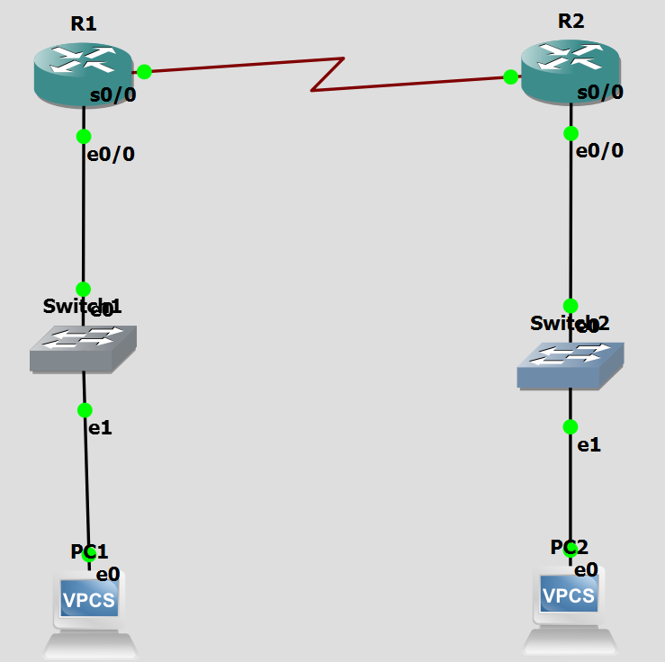

### **Working Procedure:**

Setting PC IP Addresses:

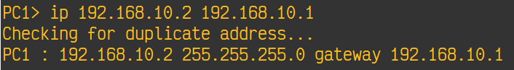

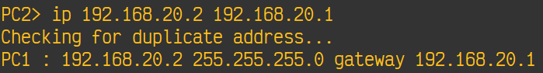

Configuring Routers:

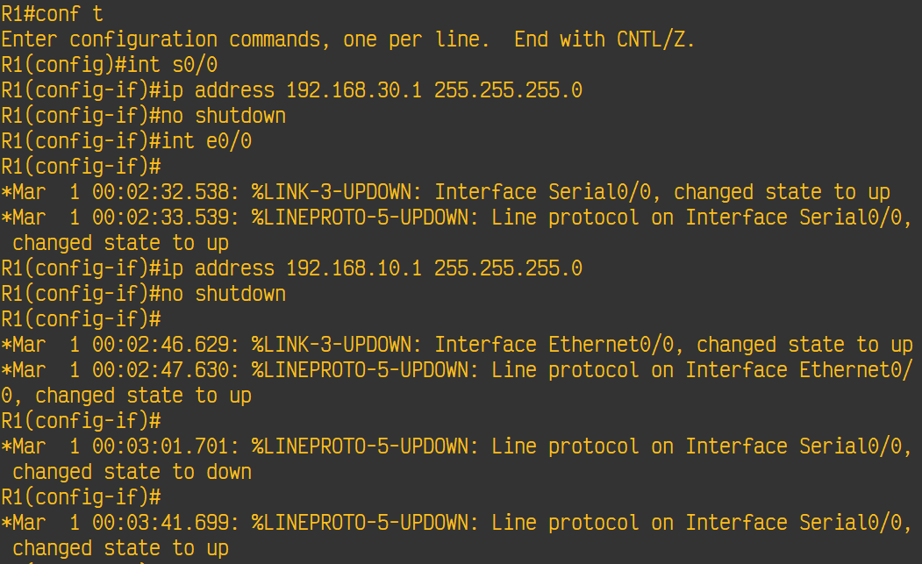

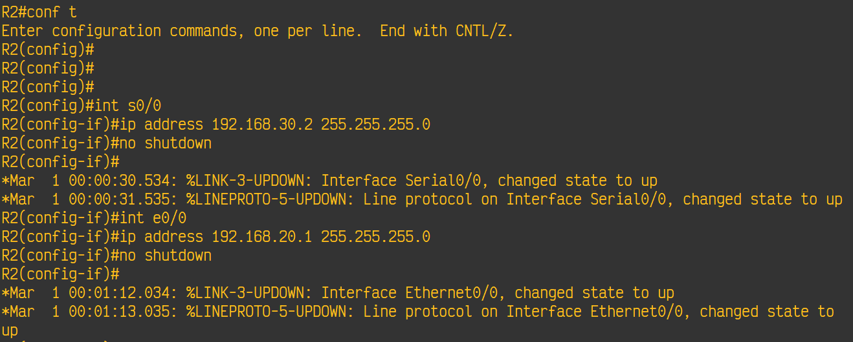

Configuring RIP:

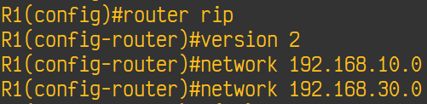

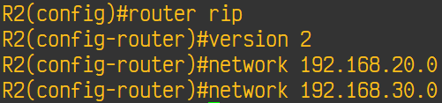

Ping:

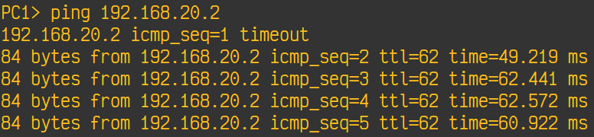

Capturing packets transmitted between R1 and R2:

